Composite Solids with Flat and Spherical Surfaces

Definition
# Source: AI Source: Provided by: [Data Path: Persons Table -> ID Column: 1, Name_En Column: Motasem Essam] -> From: [ChatGPT] on [7/25/2026]
Composite Solids with Flat and Spherical Surfaces are three-dimensional geometric solids formed by combining two or more solid components whose external boundaries include both flat surfaces and spherical curved surfaces.
These composite solids contain planar faces, such as squares, rectangles, triangles, and circles, together with spherical curved surfaces. They are commonly formed by combining spheres, hemispheres, spherical segments, or spherical caps with prisms, cubes, cylinders, pyramids, and other solid shapes.
The resulting solid may have flat bases, flat side faces, circular planar regions, and one or more spherical curved surfaces.

Simple Definition
# Source: AI Source: Provided by: [Data Path: Persons Table -> ID Column: 1, Name_En Column: Motasem Essam] -> From: [ChatGPT] on [7/25/2026]
A composite solid with flat and spherical surfaces is a 3D shape that combines flat faces with spherical curved surfaces.

Geometric Representation
# Source: AI Source: Provided by: [Data Path: Persons Table -> ID Column: 1, Name_En Column: Motasem Essam] -> From: [ChatGPT] on [7/25/2026]
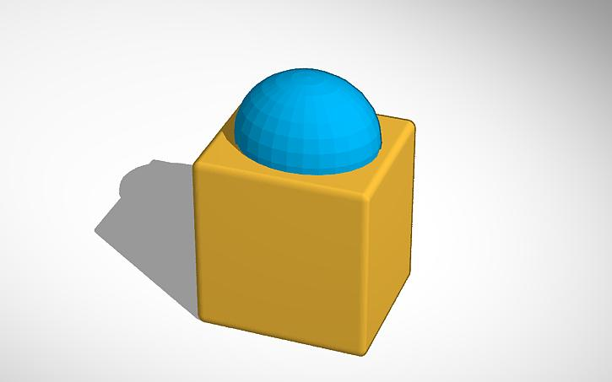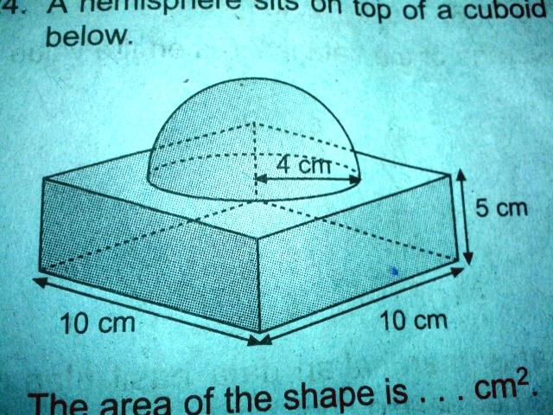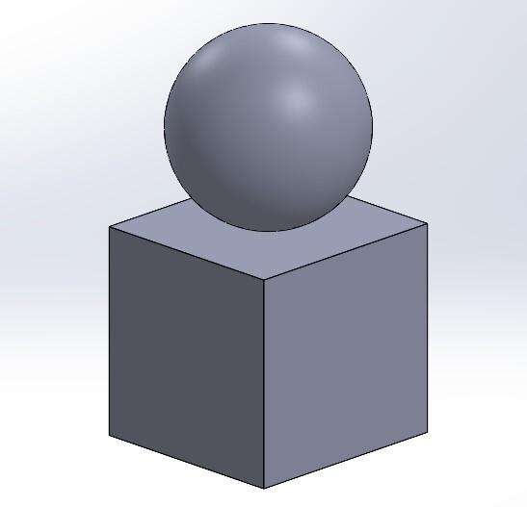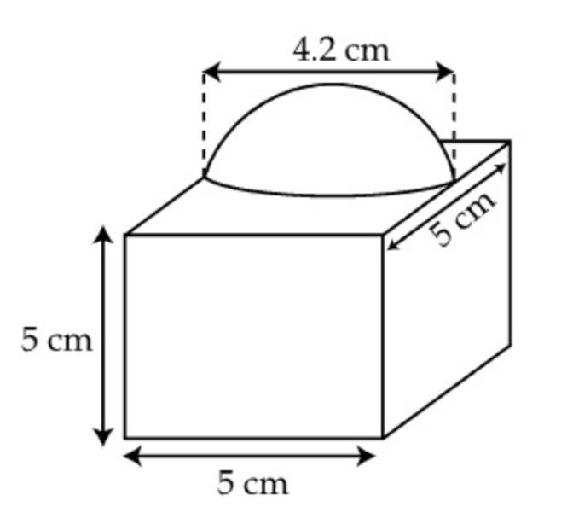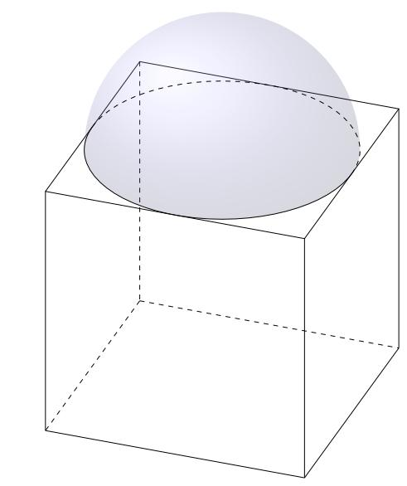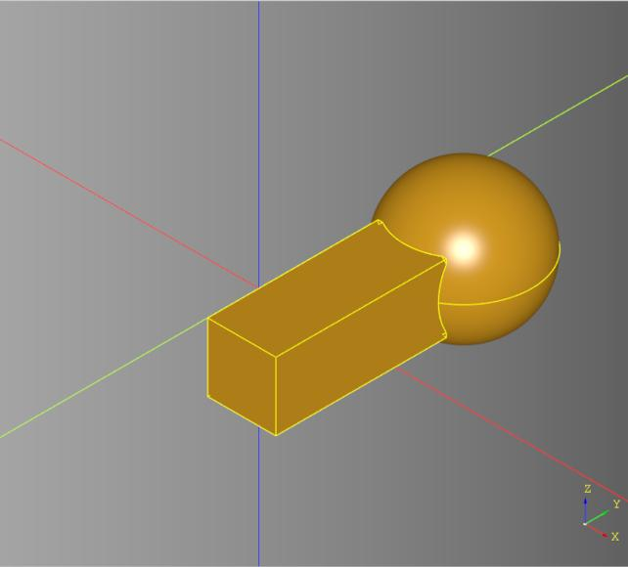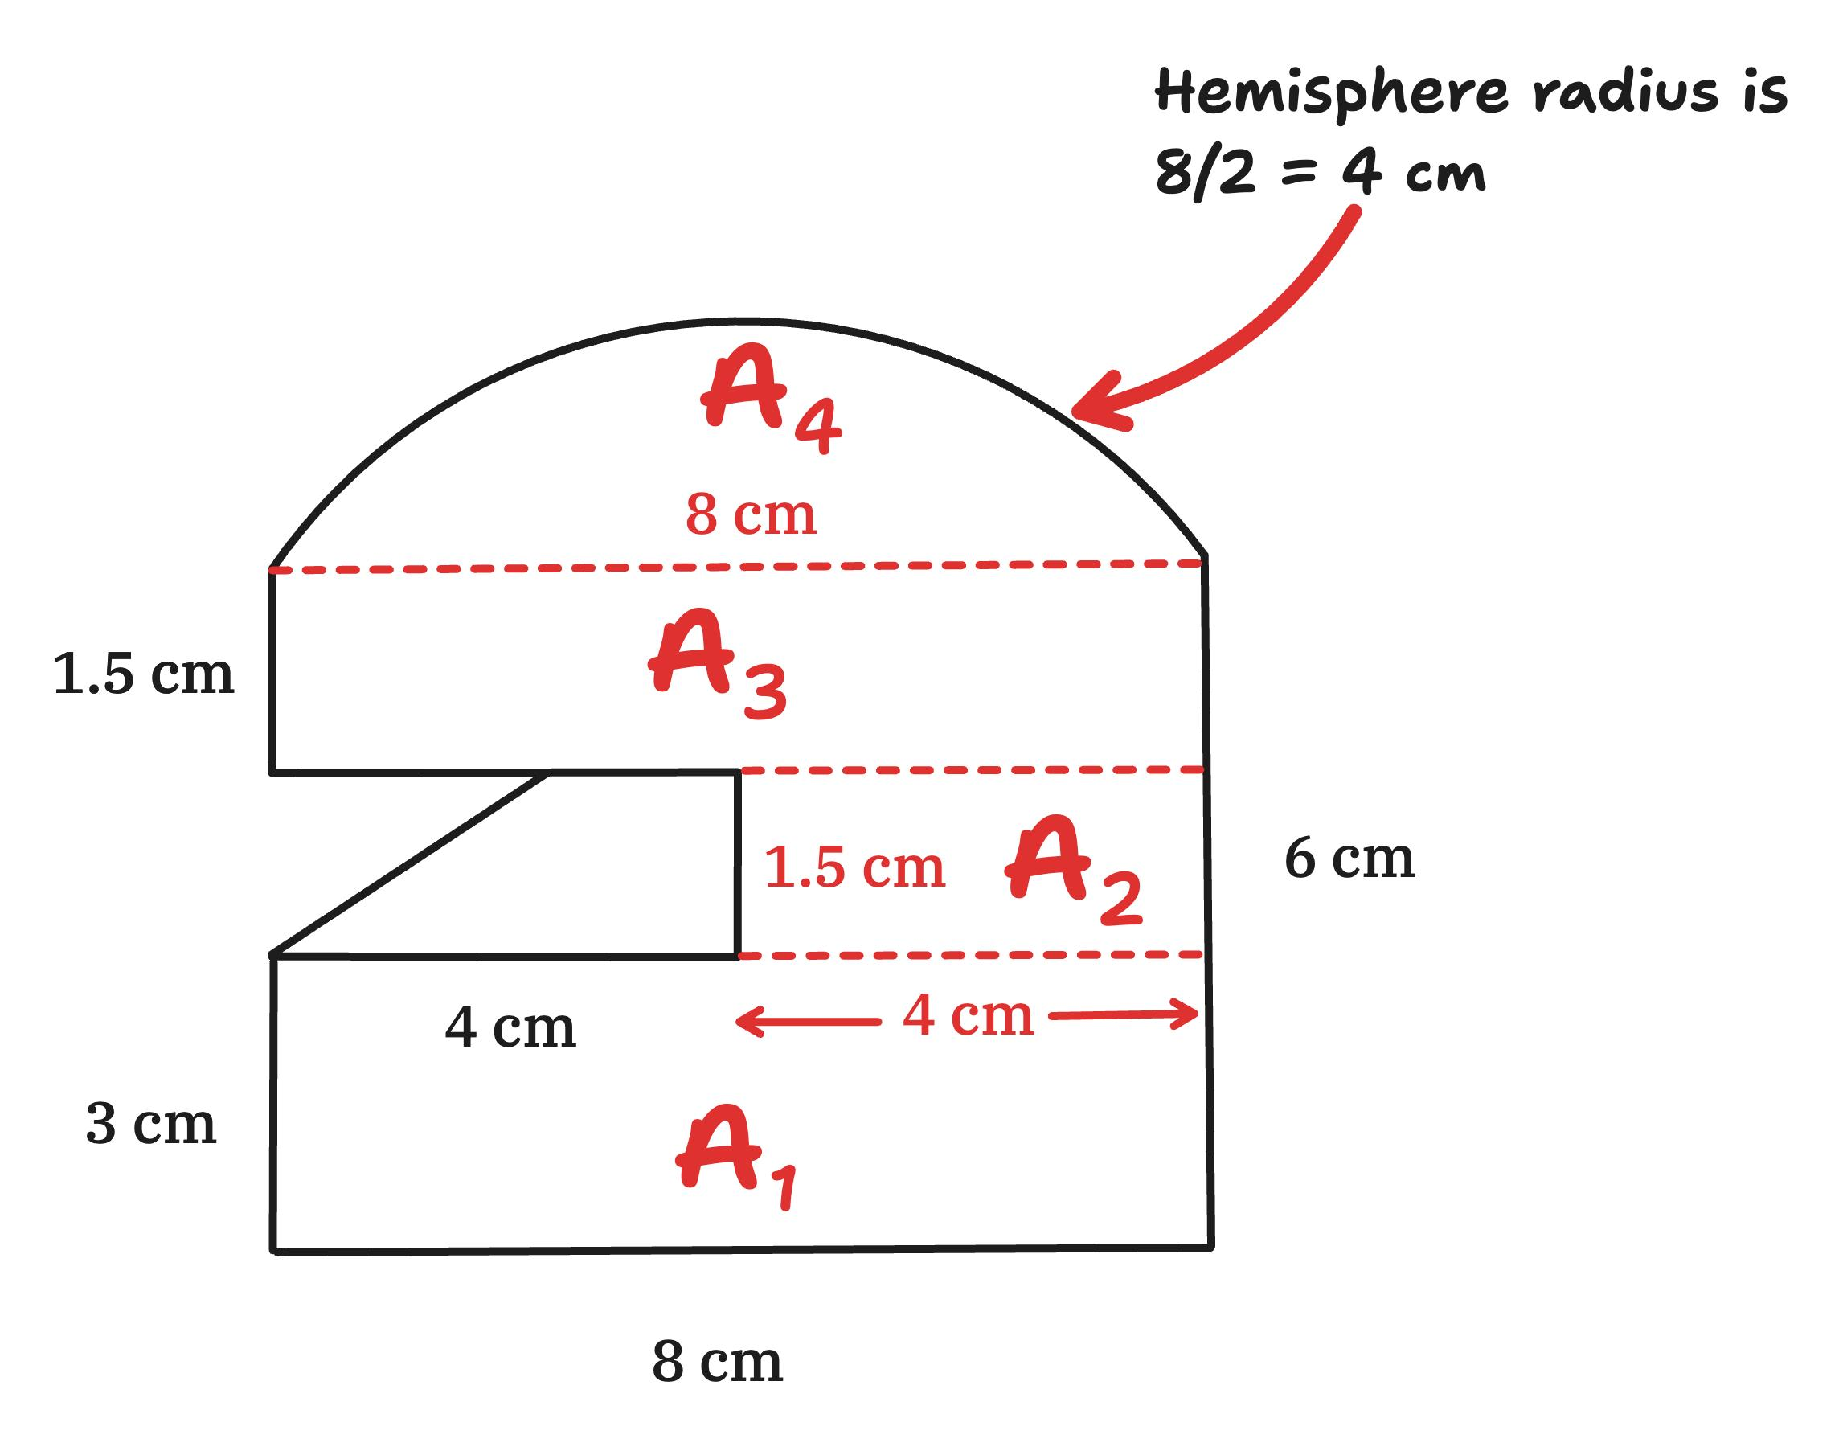
The main surface types are:
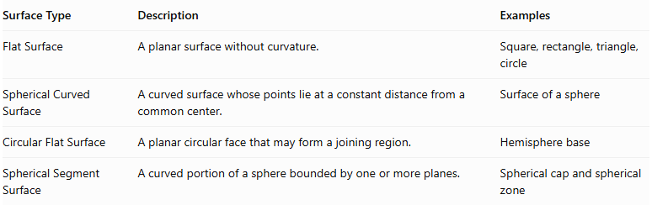
Surface Type | Description | Examples
Flat Surface | A planar surface without curvature. | Square, rectangle, triangle, circle
Spherical Curved Surface | A curved surface whose points lie at a constant distance from a common center. | Surface of a sphere
Circular Flat Surface | A planar circular face that may form a joining region. | Hemisphere base
Spherical Segment Surface | A curved portion of a sphere bounded by one or more planes. | Spherical cap and spherical zone
Important: A complete sphere has no flat faces. A hemisphere has one flat circular base and one spherical curved surface. A spherical cap has one flat circular base and one spherical curved surface.

Main Classification
# Source: AI Source: Provided by: [Data Path: Persons Table -> ID Column: 1, Name_En Column: Motasem Essam] -> From: [ChatGPT] on [7/25/2026]
Composite solids with flat and spherical surfaces can be classified according to the types of flat-faced components combined with spherical components.

Prism-Based Composite Solids
# Source: AI Source: Provided by: [Data Path: Persons Table -> ID Column: 1, Name_En Column: Motasem Essam] -> From: [ChatGPT] on [7/25/2026]
A prism-based composite solid combines one or more prisms with spheres, hemispheres, or other spherical components.
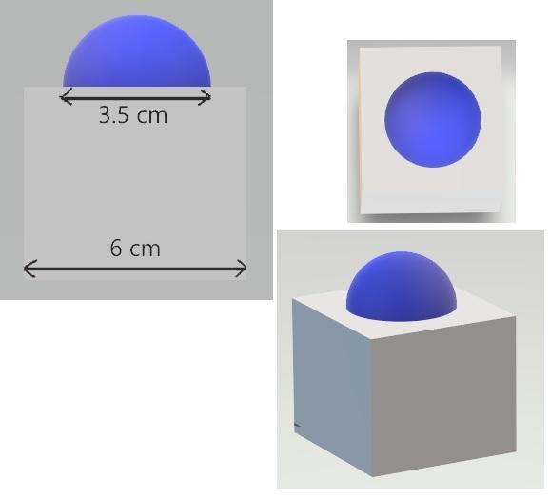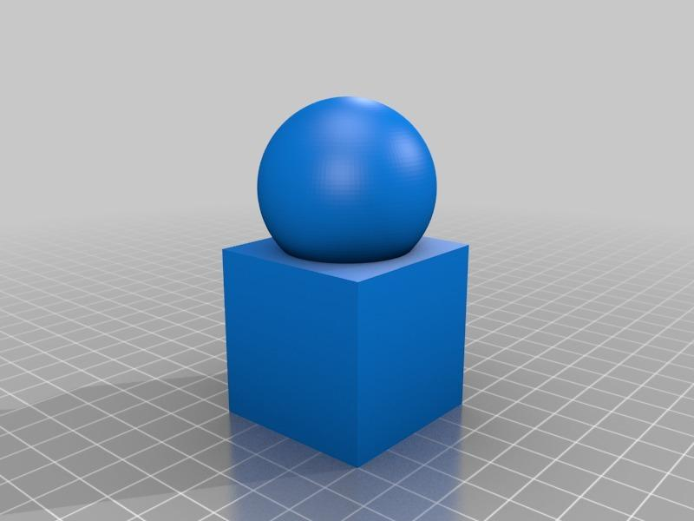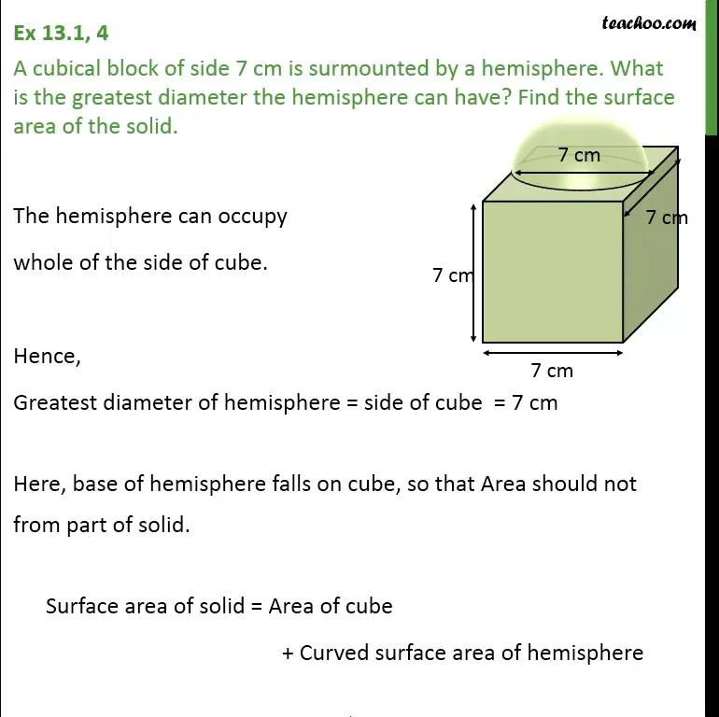
Examples:
- Rectangular Prism with a Hemisphere
- Cube with a Hemisphere
- Triangular Prism with a Hemisphere
- Polygonal Prism with a Spherical Component
- Rectangular Prism with a Spherical Cap
- Multiple Prisms with Spherical Components

Cylinder-Based Composite Solids
# Source: AI Source: Provided by: [Data Path: Persons Table -> ID Column: 1, Name_En Column: Motasem Essam] -> From: [ChatGPT] on [7/25/2026]
A cylinder-based composite solid combines cylindrical components with spheres, hemispheres, or spherical segments.
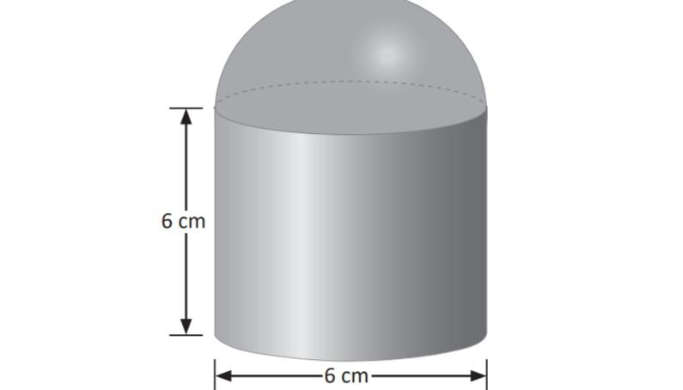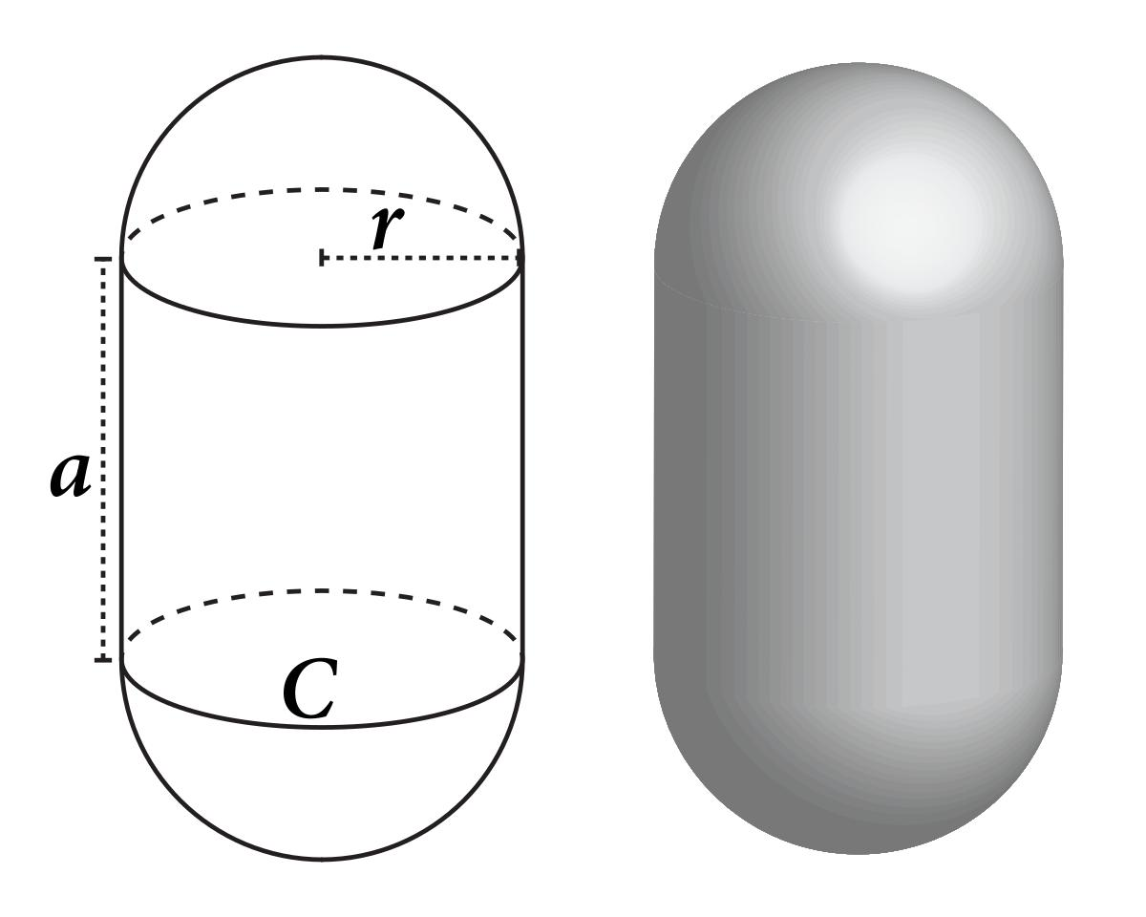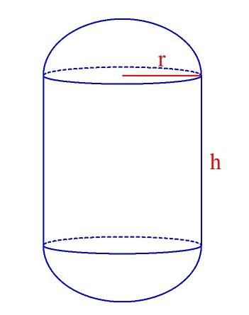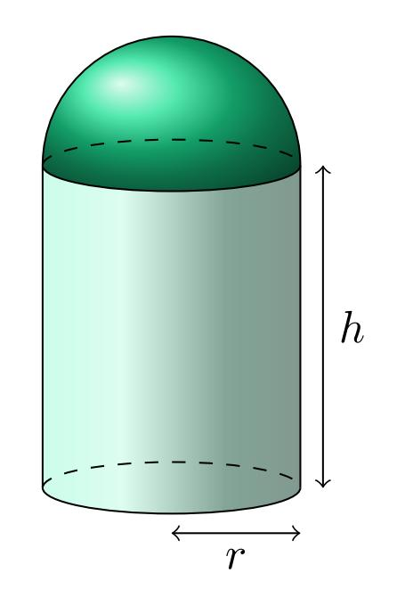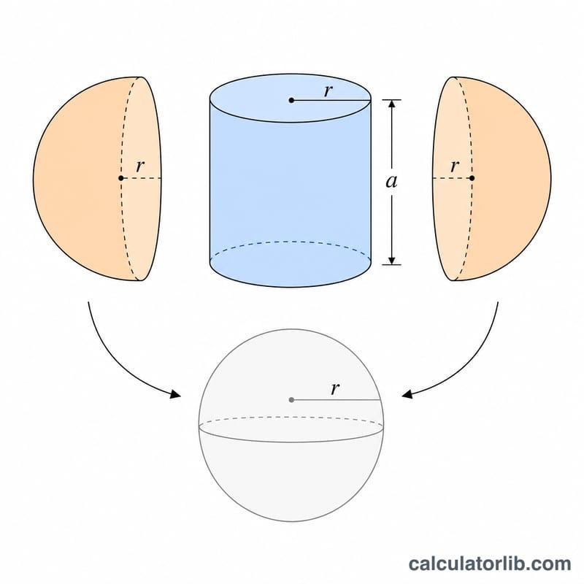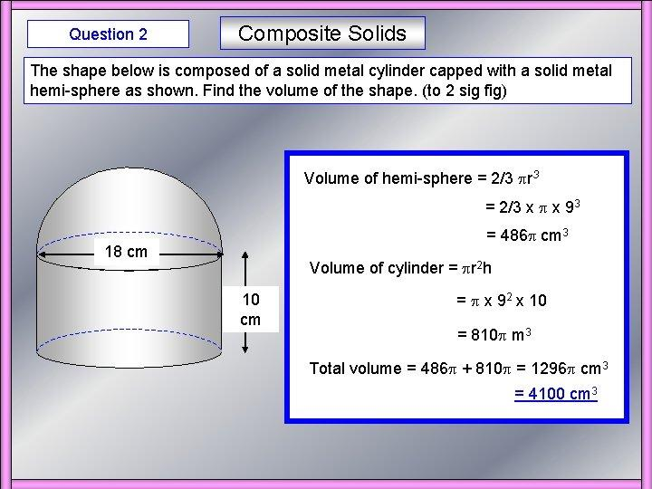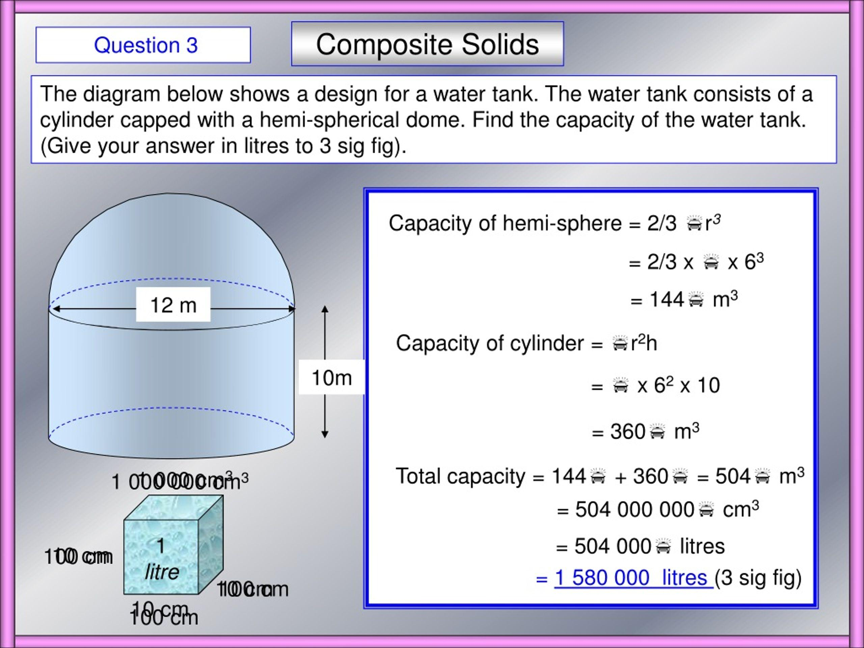
Examples:
- Cylinder with a Hemisphere
- Cylinder with a Spherical Cap
- Cylinder with a Sphere
- Cylinder with Two Hemispherical Ends
- Coaxial Cylinder and Spherical Component
- Multiple Cylinders with Spherical Components

Pyramid-Based Composite Solids
# Source: AI Source: Provided by: [Data Path: Persons Table -> ID Column: 1, Name_En Column: Motasem Essam] -> From: [ChatGPT] on [7/25/2026]
A pyramid-based composite solid combines pyramids with spheres, hemispheres, or spherical components.
Examples:
- Square Pyramid with a Hemisphere
- Triangular Pyramid with a Sphere
- Pentagonal Pyramid with a Spherical Cap
- Pyramid with a Spherical Segment
- Multiple Pyramids with Spherical Components

Sphere-Based Composite Solids
# Source: AI Source: Provided by: [Data Path: Persons Table -> ID Column: 1, Name_En Column: Motasem Essam] -> From: [ChatGPT] on [7/25/2026]
A sphere-based composite solid combines two or more spherical components, potentially with different radii, sizes, and orientations.
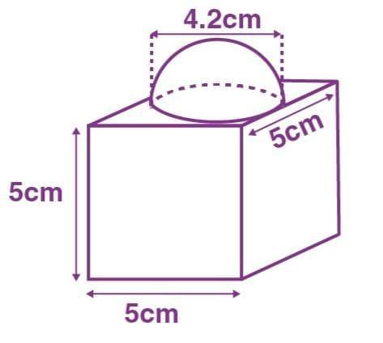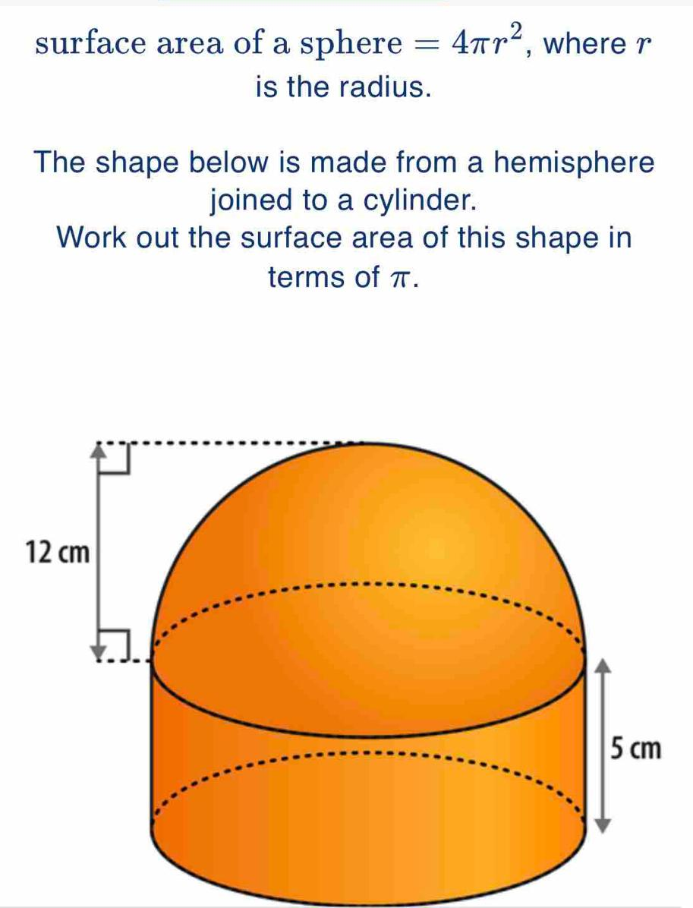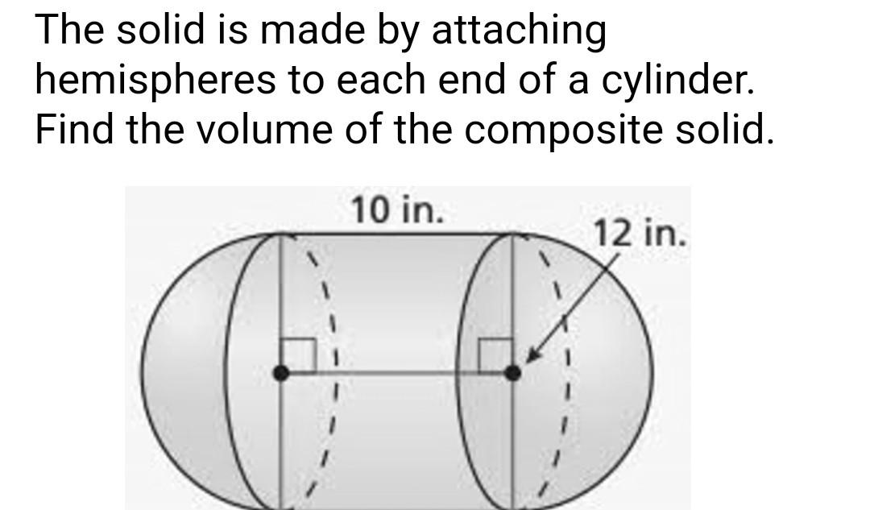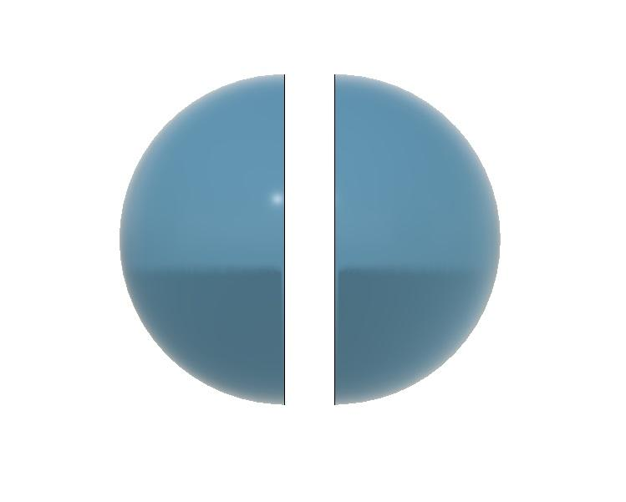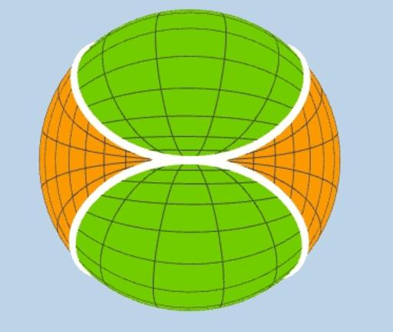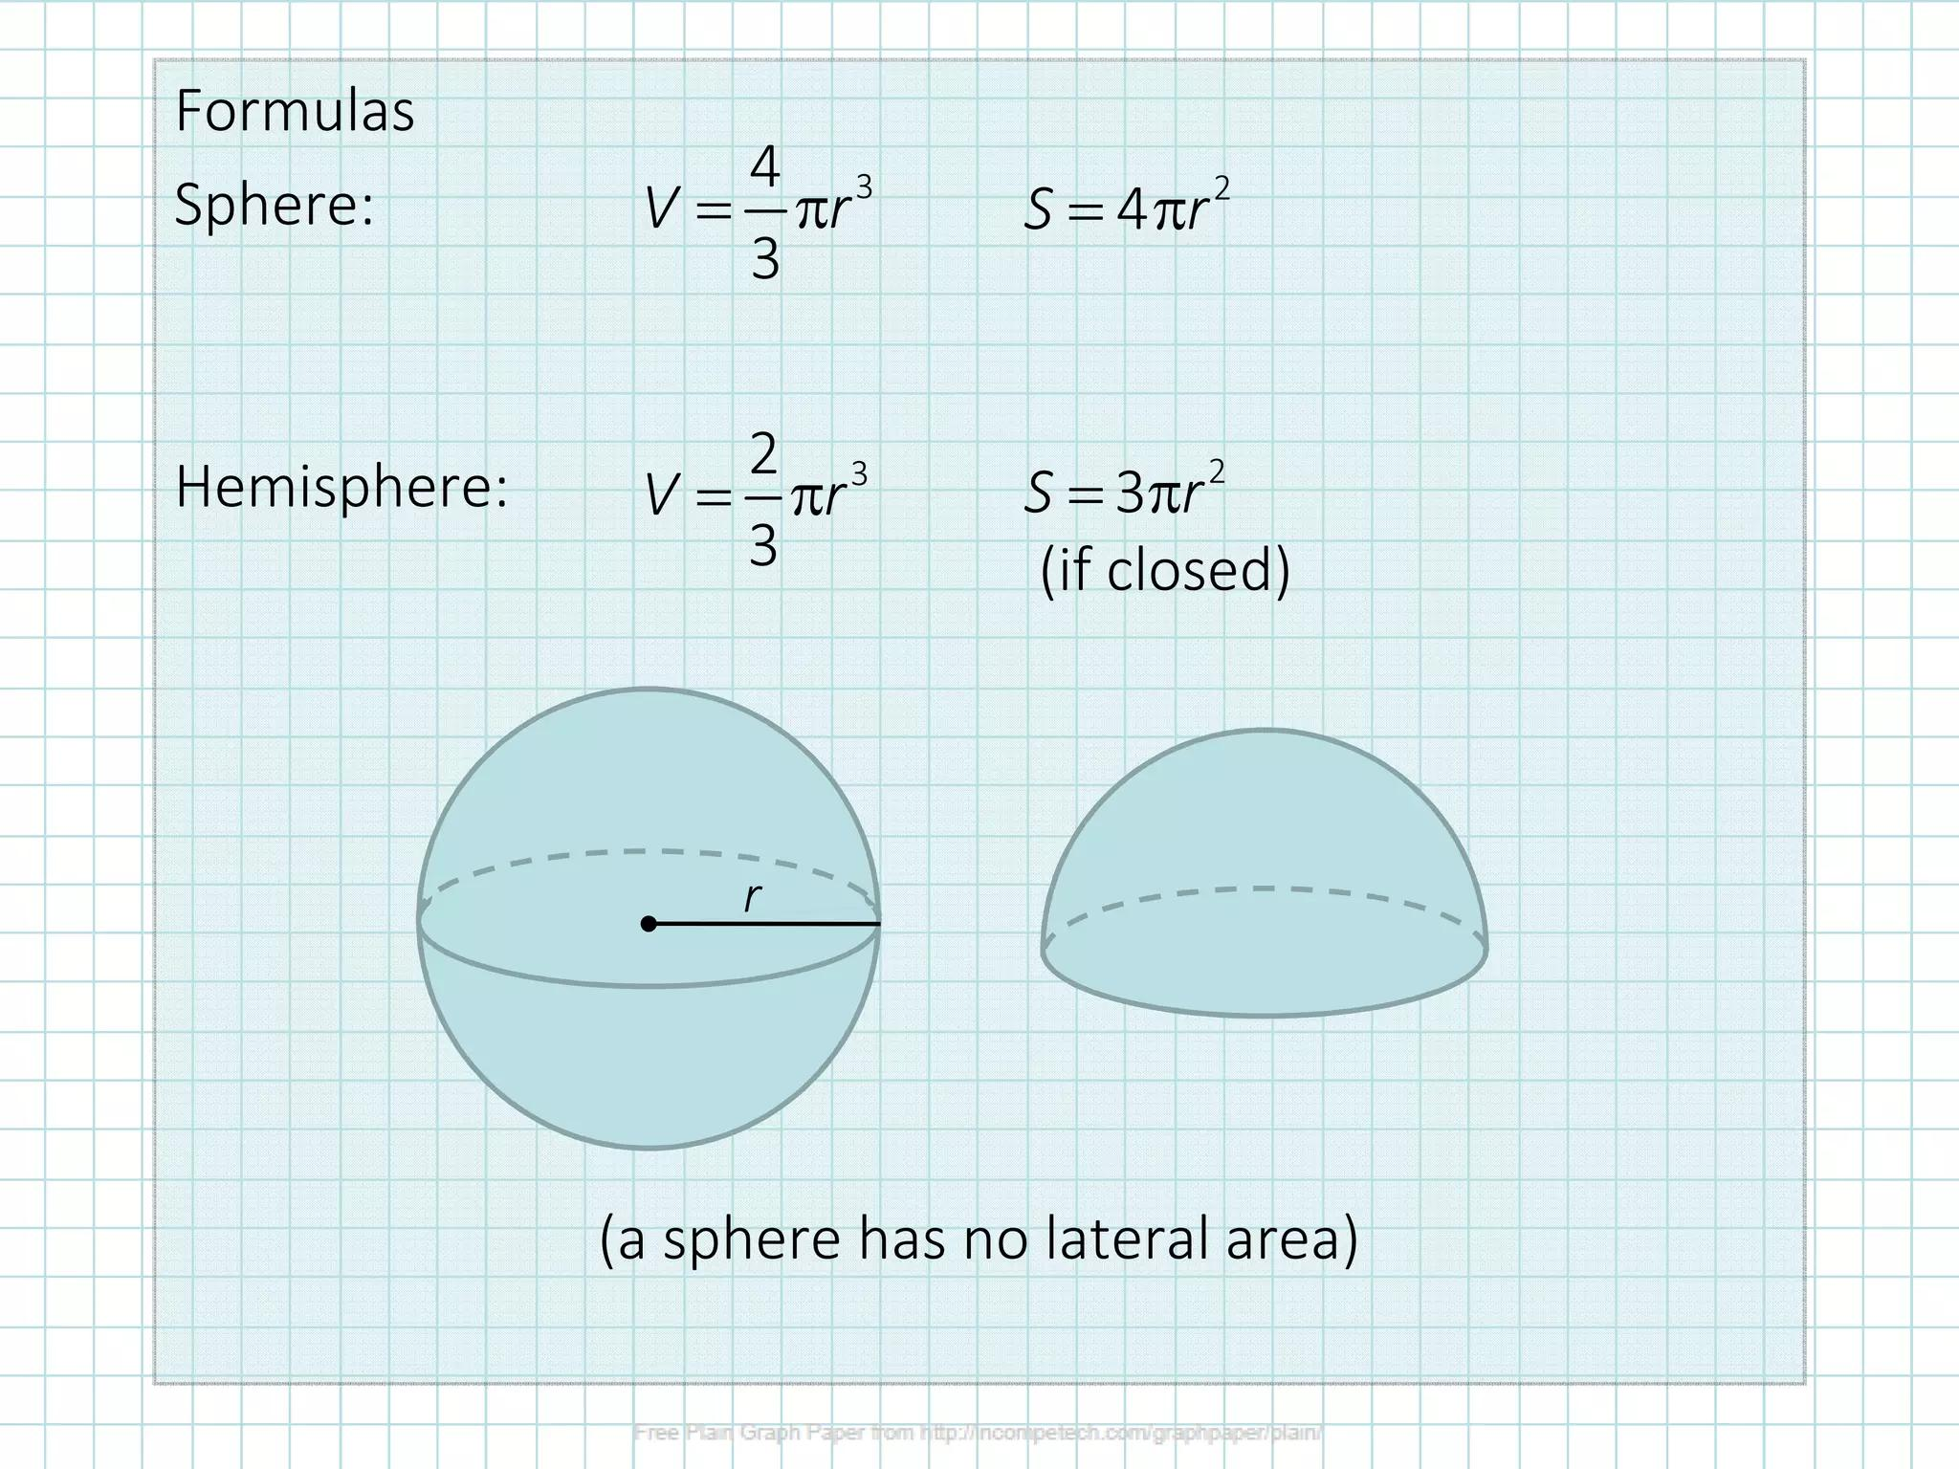
Examples:
- Two Hemispheres Joined at Their Flat Bases
- Two Spheres Joined Together
- Sphere with a Hemisphere
- Sphere with a Spherical Cap
- Multiple Spherical Components
- Spherical Components with Different Radii

Mixed-Shape Composite Solids
# Source: AI Source: Provided by: [Data Path: Persons Table -> ID Column: 1, Name_En Column: Motasem Essam] -> From: [ChatGPT] on [7/25/2026]
A mixed-shape composite solid combines spherical components with different types of flat-faced solids.
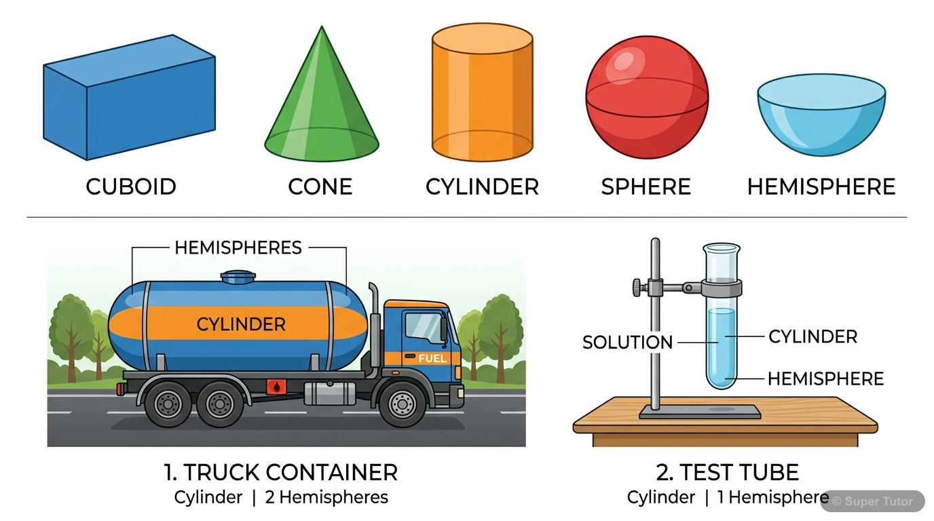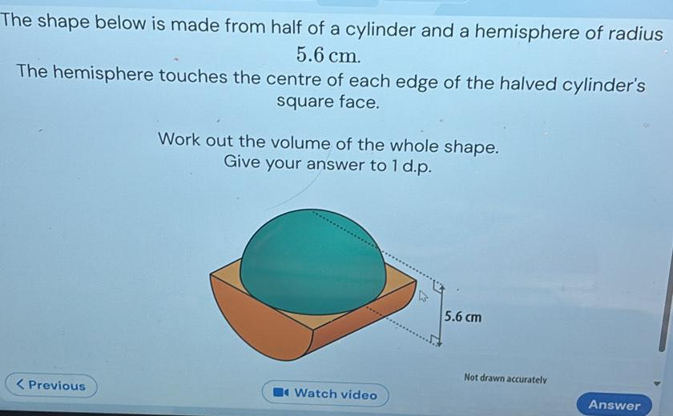
Examples:
- Hemisphere with a Cube and a Cylinder
- Sphere with a Rectangular Prism and a Pyramid
- Spherical Cap with Multiple Prisms
- Multiple Hemispheres with Different Prisms
- Complex Mixed-Shape Composite Solids

Classification by Surface Arrangement
# Source: AI Source: Provided by: [Data Path: Persons Table -> ID Column: 1, Name_En Column: Motasem Essam] -> From: [ChatGPT] on [7/25/2026]
The external surfaces can also be classified according to how flat and spherical surfaces are arranged.
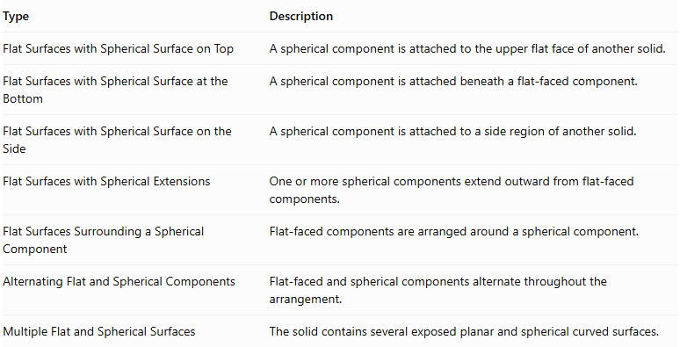
Type | Description
Flat Surfaces with Spherical Surface on Top | A spherical component is attached to the upper flat face of another solid.
Flat Surfaces with Spherical Surface at the Bottom | A spherical component is attached beneath a flat-faced component.
Flat Surfaces with Spherical Surface on the Side | A spherical component is attached to a side region of another solid.
Flat Surfaces with Spherical Extensions | One or more spherical components extend outward from flat-faced components.
Flat Surfaces Surrounding a Spherical Component | Flat-faced components are arranged around a spherical component.
Alternating Flat and Spherical Components | Flat-faced and spherical components alternate throughout the arrangement.
Multiple Flat and Spherical Surfaces | The solid contains several exposed planar and spherical curved surfaces.

Classification by Component Arrangement
# Source: AI Source: Provided by: [Data Path: Persons Table -> ID Column: 1, Name_En Column: Motasem Essam] -> From: [ChatGPT] on [7/25/2026]
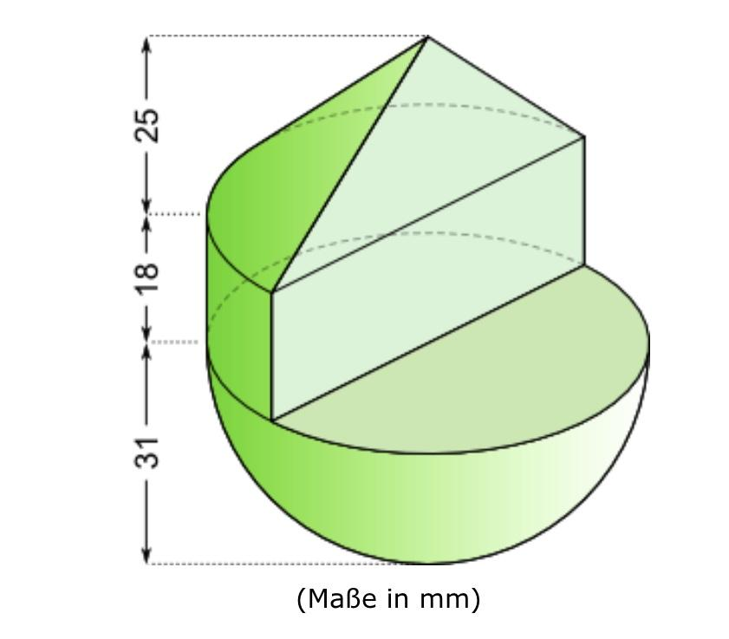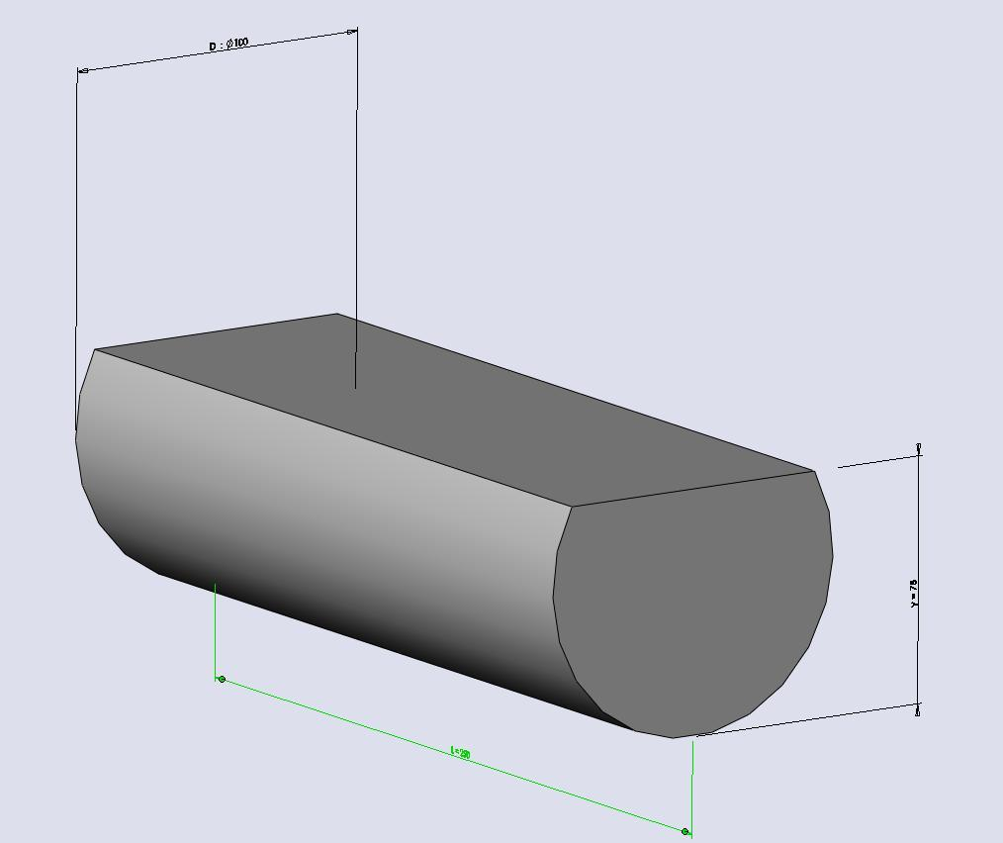
- Stacked Arrangement: Spherical and flat-faced components are placed above or below one another.
- End-to-End Arrangement: Components are connected consecutively along a common direction.
- Side-Attached Arrangement: Spherical components are attached to side faces or regions of flat-faced components.
- Coaxial Arrangement: Spherical components and cylindrical components share a common axis.
- Base-to-Base Arrangement: Hemispheres or other spherical segments are joined through their flat circular bases.
- Multi-Directional Arrangement: Components extend in different directions from a central component.

Mathematical Properties and Formulas
# Source: AI Source: Provided by: [Data Path: Persons Table -> ID Column: 1, Name_En Column: Motasem Essam] -> From: [ChatGPT] on [7/25/2026]
The volume and surface area depend on the dimensions, shapes, and joining arrangements of the component solids.

Volume
# Source: AI Source: Provided by: [Data Path: Persons Table -> ID Column: 1, Name_En Column: Motasem Essam] -> From: [ChatGPT] on [7/25/2026]
For components joined without overlapping interiors:
$$V_{total}=\sum_{i=1}^{n}{V_{i}}$$
For a composite solid containing a rectangular prism and a hemisphere:
$$V_{total}=V_{prism}+V_{hemisphere}$$
Rectangular prism:
$$V_{p}=lwh$$
Sphere:
<LearningViz typeid="SPHEREVOLUME" initial_values={{"radius":3}} />
Hemisphere:
$$V_{h}=\frac{2}{3}πr^{3}$$
Therefore:
$$\boxed{V_{total}=lwh+\frac{2}{3}πr^{3}}$$
Other useful spherical volume formulas:
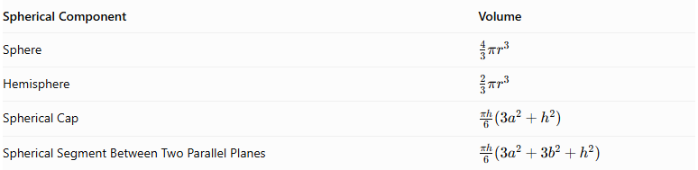
Spherical Component | Volume
Sphere | $$\frac{4}{3}πr^{3}$$
Hemisphere | $$\frac{2}{3}πr^{3}$$
Spherical Cap | $$\frac{πh}{6}(3a^{2}+h^{2})$$
Spherical Segment Between Two Parallel Planes | $$\frac{πh}{6}(3a^{2}+3b^{2}+h^{2})$$
For a spherical cap:
- $r$ = radius of the original sphere.
- $h$ = cap height.
- $a$ = radius of the cap's circular base.

Surface Area
# Source: AI Source: Provided by: [Data Path: Persons Table -> ID Column: 1, Name_En Column: Motasem Essam] -> From: [ChatGPT] on [7/25/2026]
The external surface area is calculated by adding the exposed surfaces of all components and excluding hidden joining regions.
For a rectangular prism:
$${SA}_{p}=2(lw+lh+wh)$$
For a sphere:
$${SA}_{s}=4πr^{2}$$
For a hemisphere:
$${CSA}_{h}=2πr^{2}$$
$${SA}_{h}=3πr^{2}$$
Where:
- ${CSA}_{h}$ = curved surface area of a hemisphere.
- ${SA}_{h}$ = total surface area of a hemisphere, including its flat circular base.
If a hemisphere is attached to a rectangular prism through its entire circular base, the circular joining region is hidden on both components:
$${SA}_{total}={SA}_{p}+3πr^{2}-2πr^{2}$$
Simplifying:
$$\boxed{{SA}_{total}={SA}_{p}+πr^{2}}$$
This assumes the hemisphere's circular base is completely contained within one flat face of the prism and no other surfaces overlap.
Important: A complete sphere attached to a flat face at a single point does not have a hidden joining area because point contact has zero surface area. The sphere's entire curved surface remains exposed.

Worked Examples

Example 1: Rectangular Prism with a Hemisphere on Top
# Source: AI Source: Provided by: [Data Path: Persons Table -> ID Column: 1, Name_En Column: Motasem Essam] -> From: [ChatGPT] on [7/25/2026]
Given:
- Rectangular prism: $10×8×6$ cm.
- Hemisphere radius: $2$ cm.
- The hemisphere is attached to the top face, with its circular base completely inside that face.
Step 1: Calculate the rectangular prism volume.
$$V_{p}=10×8×6=480$$
Step 2: Calculate the hemisphere volume.
$$V_{h}=\frac{2}{3}π(2)^{3}$$
$$V_{h}=\frac{16π}{3}$$
Step 3: Calculate total volume.
$$V=480+\frac{16π}{3}$$
$$\boxed{V≈496.76{ cm}^{3}}$$
Step 4: Calculate the rectangular prism surface area.
$${SA}_{p}=2(10×8+10×6+8×6)$$
$${SA}_{p}=376{ cm}^{2}$$
Step 5: Calculate the exposed hemisphere curved surface area.
$${CSA}_{h}=2π(2)^{2}$$
$${CSA}_{h}=8π$$
Step 6: Calculate the external surface area.
The hemisphere's circular base is hidden, and the corresponding circular region on the prism is also hidden:
$$SA=376+8π$$
$$\boxed{SA≈401.13{ cm}^{2}}$$

Example 2: Cylinder with Two Hemispherical Ends
# Source: AI Source: Provided by: [Data Path: Persons Table -> ID Column: 1, Name_En Column: Motasem Essam] -> From: [ChatGPT] on [7/25/2026]
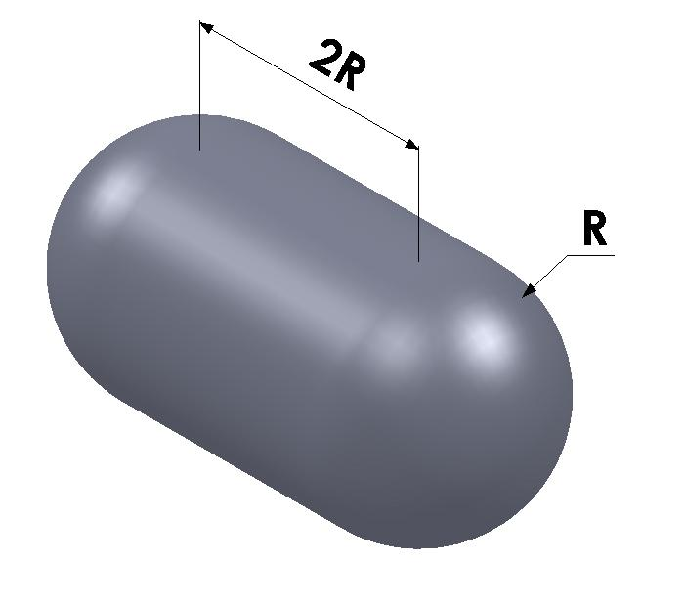
Given:
- Cylinder radius: $3$ cm.
- Cylinder height: $8$ cm.
- Two hemispheres, each with radius $3$ cm.
- Both hemispheres are attached to the two circular ends of the cylinder.
Step 1: Calculate the cylinder volume.
$$V_{c}=π(3)^{2}(8)$$
$$V_{c}=72π$$
Step 2: Calculate the volume of two hemispheres.
Two hemispheres form one complete sphere:
$$V_{h}=\frac{4}{3}π(3)^{3}$$
$$V_{h}=36π$$
Step 3: Calculate total volume.
$$V=72π+36π$$
$$\boxed{V=108π≈339.29{ cm}^{3}}$$
Step 4: Calculate the cylinder's exposed curved surface area.
The two circular bases are hidden by the hemispheres:
$${CSA}_{c}=2πrh$$
$${CSA}_{c}=2π(3)(8)=48π$$
Step 5: Calculate the curved surface area of two hemispheres.
$${CSA}_{h}=2(2πr^{2})$$
$${CSA}_{h}=4π(3)^{2}$$
$${CSA}_{h}=36π$$
Step 6: Calculate total external surface area.
$$SA=48π+36π$$
$$\boxed{SA=84π≈263.89{ cm}^{2}}$$

Important Characteristics
# Source: AI Source: Provided by: [Data Path: Persons Table -> ID Column: 1, Name_En Column: Motasem Essam] -> From: [ChatGPT] on [7/25/2026]
- Mixed Surface Geometry: The solid contains planar surfaces and spherical curved surfaces.
- Multiple Components: It is constructed from two or more geometric solids.
- Spherical Components: These may include spheres, hemispheres, spherical caps, and spherical segments.
- Flat Joining Regions: Components can connect through complete or partial planar regions.
- Variable Orientation: Spherical components can be placed above, below, beside, or around other solids.
- Variable Dimensions: Components may have different radii, heights, and base dimensions.
- Volume Calculation: Component volumes are added when their interiors do not overlap.
- Surface Area Calculation: Only exposed surfaces contribute to the external surface area.

Comparison with Other Surface Combinations
# Source: AI Source: Provided by: [Data Path: Persons Table -> ID Column: 1, Name_En Column: Motasem Essam] -> From: [ChatGPT] on [7/25/2026]
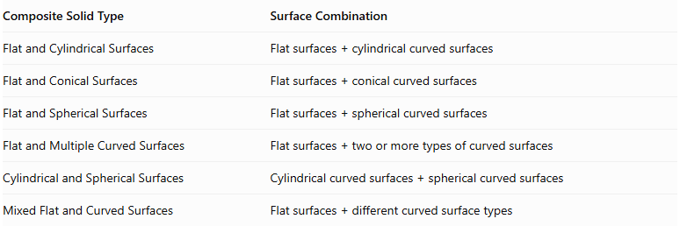
Composite Solid Type | Surface Combination
Flat and Cylindrical Surfaces | $$Flatsurfaces+cylindricalcurvedsurfaces$$
Flat and Conical Surfaces | $$Flatsurfaces+conicalcurvedsurfaces$$
Flat and Spherical Surfaces | $$Flatsurfaces+sphericalcurvedsurfaces$$
Flat and Multiple Curved Surfaces | $$Flatsurfaces+twoormoretypesofcurvedsurfaces$$
Cylindrical and Spherical Surfaces | $$Cylindricalcurvedsurfaces+sphericalcurvedsurfaces$$
Mixed Flat and Curved Surfaces | $$Flatsurfaces+differentcurvedsurfacetypes$$

Applications
# Source: AI Source: Provided by: [Data Path: Persons Table -> ID Column: 1, Name_En Column: Motasem Essam] -> From: [ChatGPT] on [7/25/2026]
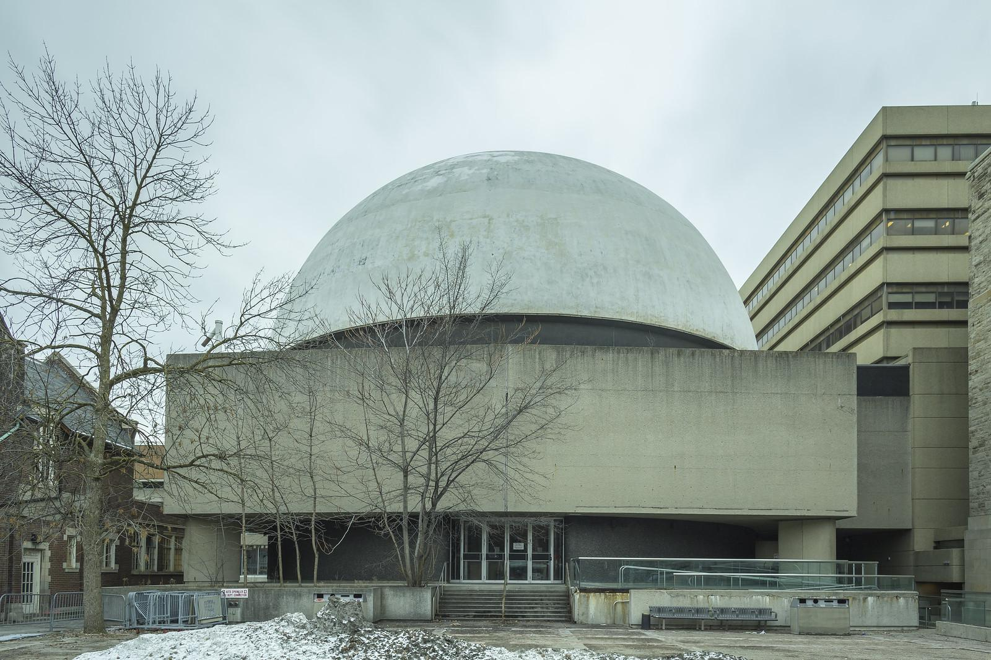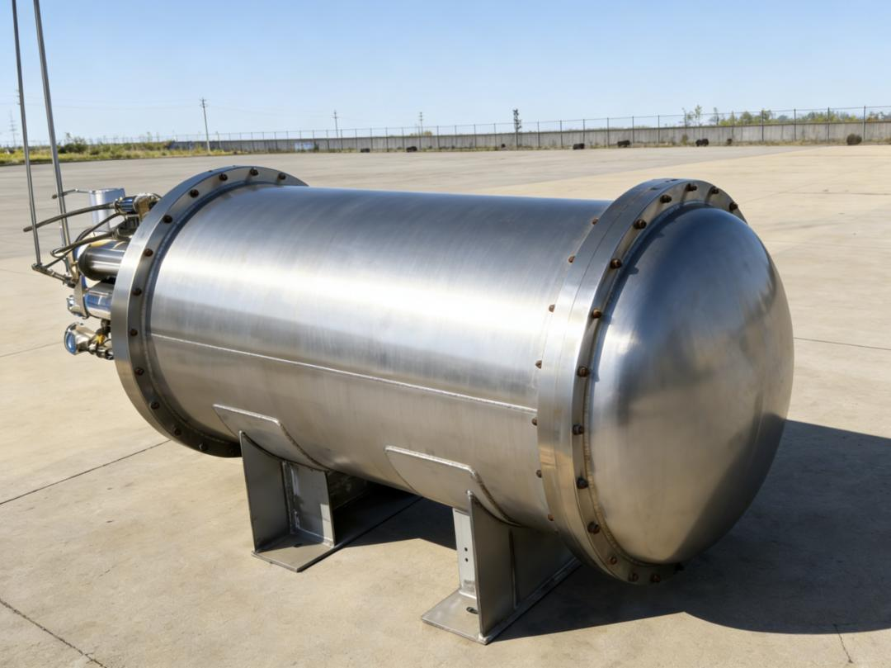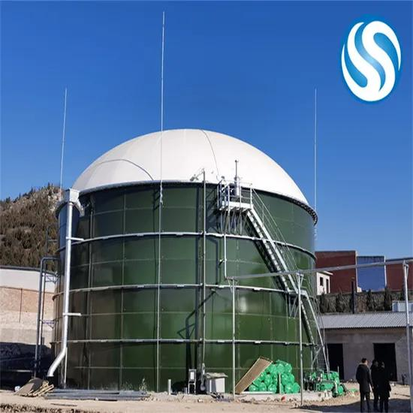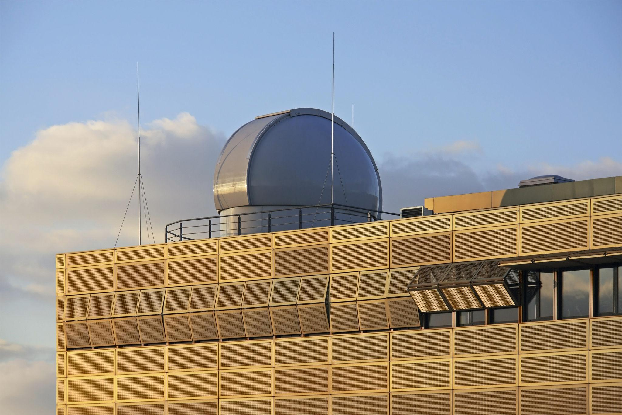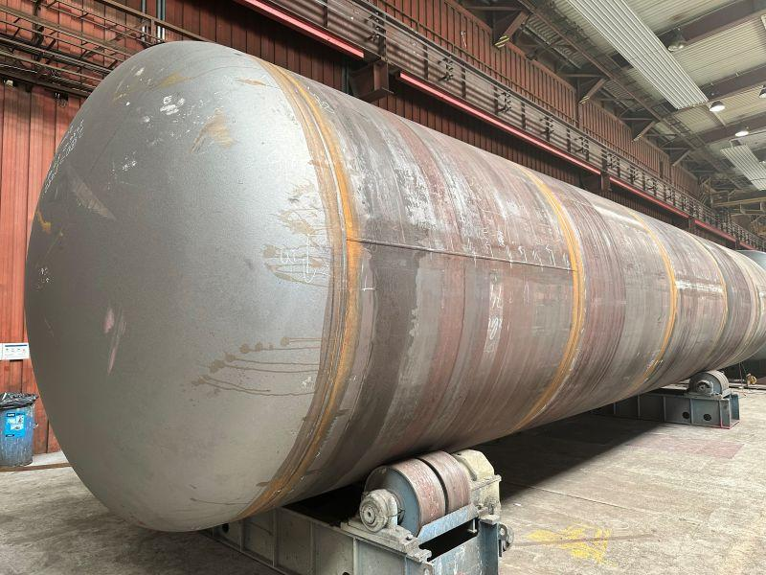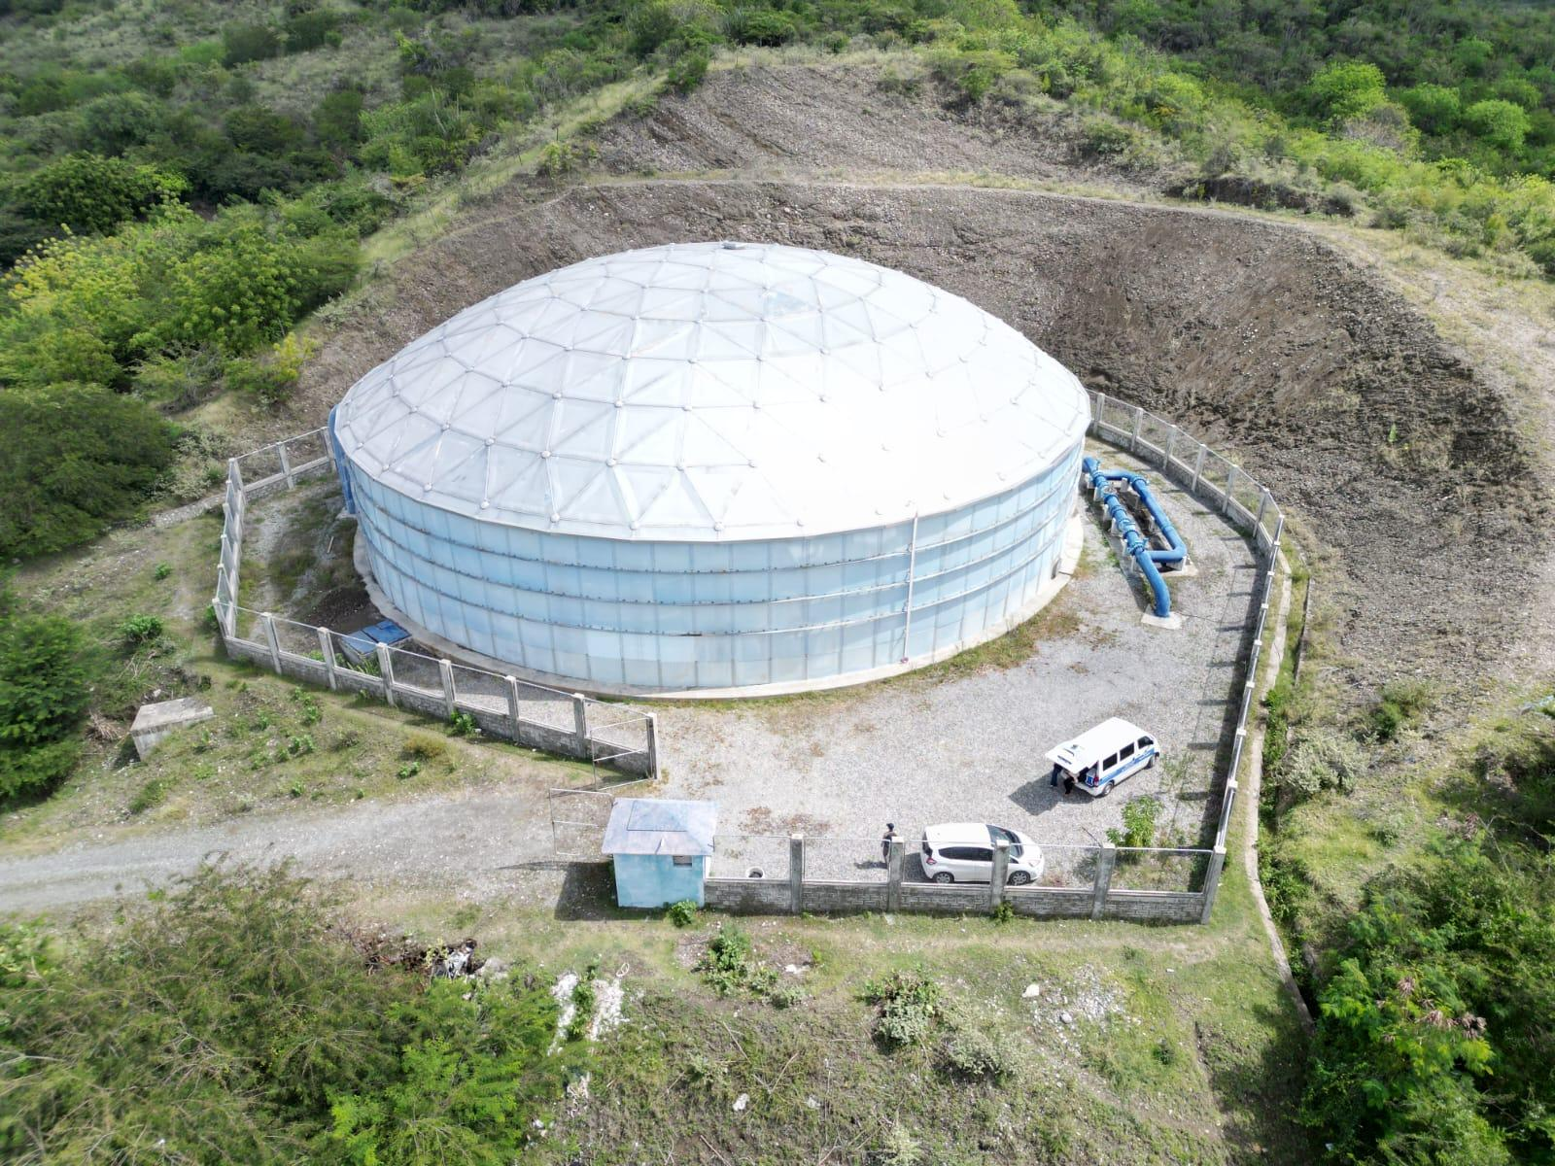
- Architecture: Buildings with hemispherical domes supported by rectangular structures.
- Industrial Storage: Pressure vessels and tanks with hemispherical ends.
- Mechanical Engineering: Components combining spherical surfaces with flat supporting structures.
- Construction: Domes and spherical caps attached to flat-faced buildings.
- Product Design: Objects combining flat bases with spherical or hemispherical components.

Key Points
# Source: AI Source: Provided by: [Data Path: Persons Table -> ID Column: 1, Name_En Column: Motasem Essam] -> From: [ChatGPT] on [7/25/2026]
- These composite solids combine flat surfaces with spherical curved surfaces.
- They can include prisms, cubes, cylinders, pyramids, spheres, hemispheres, and spherical segments.
- Their arrangements include stacked, side-attached, coaxial, base-to-base, and end-to-end configurations.
- Spherical volume depends on the radius, while spherical cap volume also depends on its height and base radius.
- Hidden joining regions must be excluded when calculating external surface area.
- A complete sphere has no flat joining face; a hemisphere and spherical cap do.

Conclusion
# Source: AI Source: Provided by: [Data Path: Persons Table -> ID Column: 1, Name_En Column: Motasem Essam] -> From: [ChatGPT] on [7/25/2026]
Composite Solids with Flat and Spherical Surfaces are three-dimensional structures that combine planar faces with spherical curved surfaces. They can be constructed from different combinations of prisms, cylinders, pyramids, spheres, hemispheres, and spherical segments.
Their geometric analysis requires calculating the volume of each component and identifying the exposed surfaces while excluding hidden joining regions.

